A.B.A.T.E. of MN Young Riders

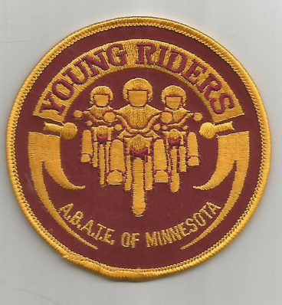

Benefits of membership
Provide opportunities to advance motorcycle use and safety while participating in civic activities
New members will receive a Young Riders patch, all members will receive a membership card, communication about events and activities suitable for their participation.

Membership Groups
Those that have not reached their 16th birthday when they apply will be designated as Pre-16 Young Riders members. Members of those 16 years of age or older when they apply will be recognized as Young Riders.

A.B.A.T.E. of MN Young Riders
Membership Application

First Name__________________________

Middle_____________________________

Last Name__________________________

Address 1___________________________

Address 2___________________________

City_____________ State____ Zip_______

Phone _____-_____-_____

Email______________________________

Age category: Under 16 ☐
Over age 16 Under age 18 ☐ 18 or over ☐

Birthdate (mm)____ / (dd)____ / (yy)____

Membership Fee $10.00
Payable to: A.B.A.T.E. of MN
Check #_______

Charge: Visa ☐ Mastercard ☐

Card # _______-_______-_______-_______

Expiration Date (mm)_______ / (yy)______

CVV #______

Card Holder Name (print)

___________________________________

Card Holder Signature

___________________________________

Submit completed application to:
Young Riders Program
c/o Stephanie Christensen
242 8th Street NW
Elk River, MN 55330

