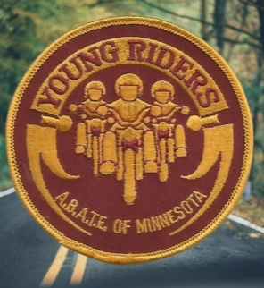

Many of the Young Rider expenses can be covered with charitable gambling funds but some expenses will need to be paid with A.B.A.T.E. of Minnesota general funds.
THE PLAN!
We are offering the opportunity to become “Proud supporter of A.B.A.T.E. Young Riders”. At this time private parties may be listed as ““Proud supporter of A.B.A.T.E. Young Riders” at a small donation of $200.00 per year. A.B.A.T.E. chapters can be listed as “Proud supporter of A.B.A.T.E. Young Riders” at a fee of $400.00 per year. Either group may participate in 6-month increments. We plan to offer a business or commercial Supporter opportunity later.
How it works, make a minimum $100.00 personal donation, $200.00 chapter donation (Not a business donation) and we will recognize the donor as a “Proud supporter of A.B.A.T.E. Young Riders” for six consecutive months, double the donation we double the time.
Our method of recognizing donors will be to post their name and the donation period covered in Road Noise, on our Web Site and on the Young Riders Facebook page.

You can become a Young Rider Supporter
Donations should be forwarded to:
A.B.A.T.E. of MN State Treasurer
Michelle Backlund
16550 226th Ave NW, Elk River, MN 55330
"Donations to A.B.A.T.E. of Minnesota or A.B.A.T.E. Young Riders are not tax deductible.”

