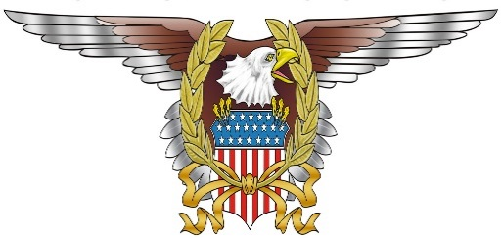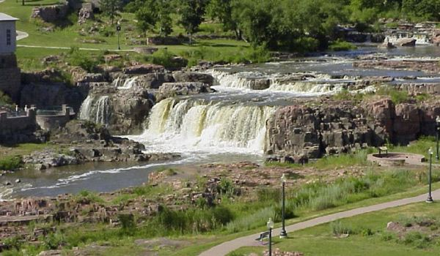 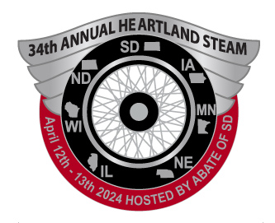

Mail in Registration with check or money order payable to - **ABATE of South Dakota**.

______$50.00 on or before March 11th, 2024 ______$60.00 fee after March 11th, 2024

T-shirt is not included in registration price. Please complete the following if interested.

T-shirt size__________ T-shirt color (circle one) Black or Grey T-shirt $20.00 extra

Mail to - **ABATE of South Dakota** **2605 Kingston Dr**  **Sioux Falls SD 57107**

Questions and Credit Card Registration - call #605-201-1748 or email TG912@sio.midco.net

Name:

ABATE/SMRO:

Postal Address:

City: State: Zip:

Email: Phone:

**Heartland STEAM is a fundraiser for the**

**M.R.F. - Motorcycle Riders Foundation**

Join members of motorcycle rights groups from South Dakota, North Dakota, Wisconsin, Illinois, Nebraska, Minnesota and Iowa as we discuss information and training to assist motorcyclists in defending, building and strengthening their organizations.

3200 W. Maple Street Ask for the MRF/Heartland STEAM Sioux Falls, SD 57107 block of rooms - $139.99 per night #605-336-0650 www.SiouxFalls.BWRamkota.com

***April 12-13, 2024 Best Western Ramkota – Sioux Falls, SD***

***A Seminar to Educate and Motivate***

**34th Annual Heartland STEAM**

***A.B.A.T.E. of South Dakota***

*Hosted by*