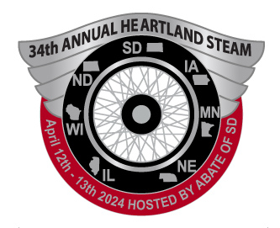
HEARTLAND S.T.E.A.M.
#243 2601 S. Minnesota Ave. STE 105
Sioux Falls, SD 57105-4750
(605) 391-6361
www.abatesd.com

The member holding this letter is asking you for a Silent Auction donation on behalf of Heartland STEAM, for our upcoming Heartland STEAM (Seminar to Educate And Motivate), April 12th & 13th, 2024 at the Best Western Ramkota Hotel in Sioux Falls.

Heartland STEAM is a regional Motorcycle Rights Conference held annually. The states attending the conference are South Dakota, North Dakota, Nebraska, Minnesota, Iowa, Wisconsin and Illinois. This year ABATE of South Dakota is the host. All the profits from the conference are given to the Motorcycle Riders Foundation.

The Motorcycle Riders Foundation (MRF), incorporated in 1987, is a membership-based national motorcyclists’ rights organization headquartered in Washington, D.C. The MRF monitors and when necessary, sways federal legislation and regulatory action that pertains to street riders. The MRF concerns itself with what is going on in the arena of motorcycling safety education, training, licensing, and public awareness. The MRF provides members and state motorcyclists’ rights organizations with direction and information to protect motorcyclists’ rights and motorcycling.

Any item or gift certificate will be greatly appreciated. This donation will help our cause and the Motorcycle Riders Foundation efforts in representing the motorcyclist’s issues in Washington DC.

Please feel free to contact us with any questions or concerns you may have. Thank you for your continued generosity and support.

Sincerely,
Jiggs Cressy
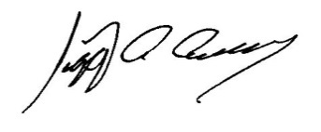
Heartland STEAM Chair
ABATE of South Dakota

